Xiao Zhou zhouxiao@bu.edu

CS 542 Problem Set 4 Report

Discussed with classmates

4/16/2017

1 vs 1 voting scheme

x:0 ,y:1

Number of Loops:17

Training Error:1.200480e-03

x:0 ,y:2

Number of Loops:26

Training Error:4.924242e-02

……

x:7 ,y:8

Number of Loops:26

Training Error:6.369427e-03

x:7 ,y:9

Number of Loops:26

Training Error:4.305043e-02

x:8 ,y:9

Number of Loops:26

Training Error:3.359173e-02

Overall Error Rate: 1.480000e-01

For 1 vs rest voting scheme, the overall error rate is 1.500000e-01, and takes significantly longer time than 1 vs 1 voting scheme. 1 vs rest takes much more time than 1 vs 1 to complete and are less accurate; possible reason is that the error is accumulated during the 1 vs rest voting scheme.

For DAGSVM, the overall error rate is 1.510000e-01

The time is:

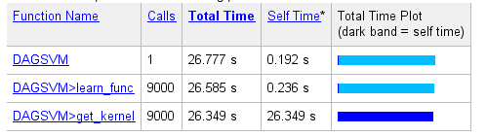

Analysis and reasoning of methods performance, relative strengths and weakness of methods

DAGSVM takes significantly less time, but it also has relative lower accuracy on the testing set. The reason it takes much less time is due to its structure, which greatly decreases its computation need by separate the individual classes with large margin and discard the losing class at each 1 vs 1 decision. DAGSVM provides a more efficient representation of redundancies and repetitions that can occur in different branches of the tree by allowing the merging of different decision paths